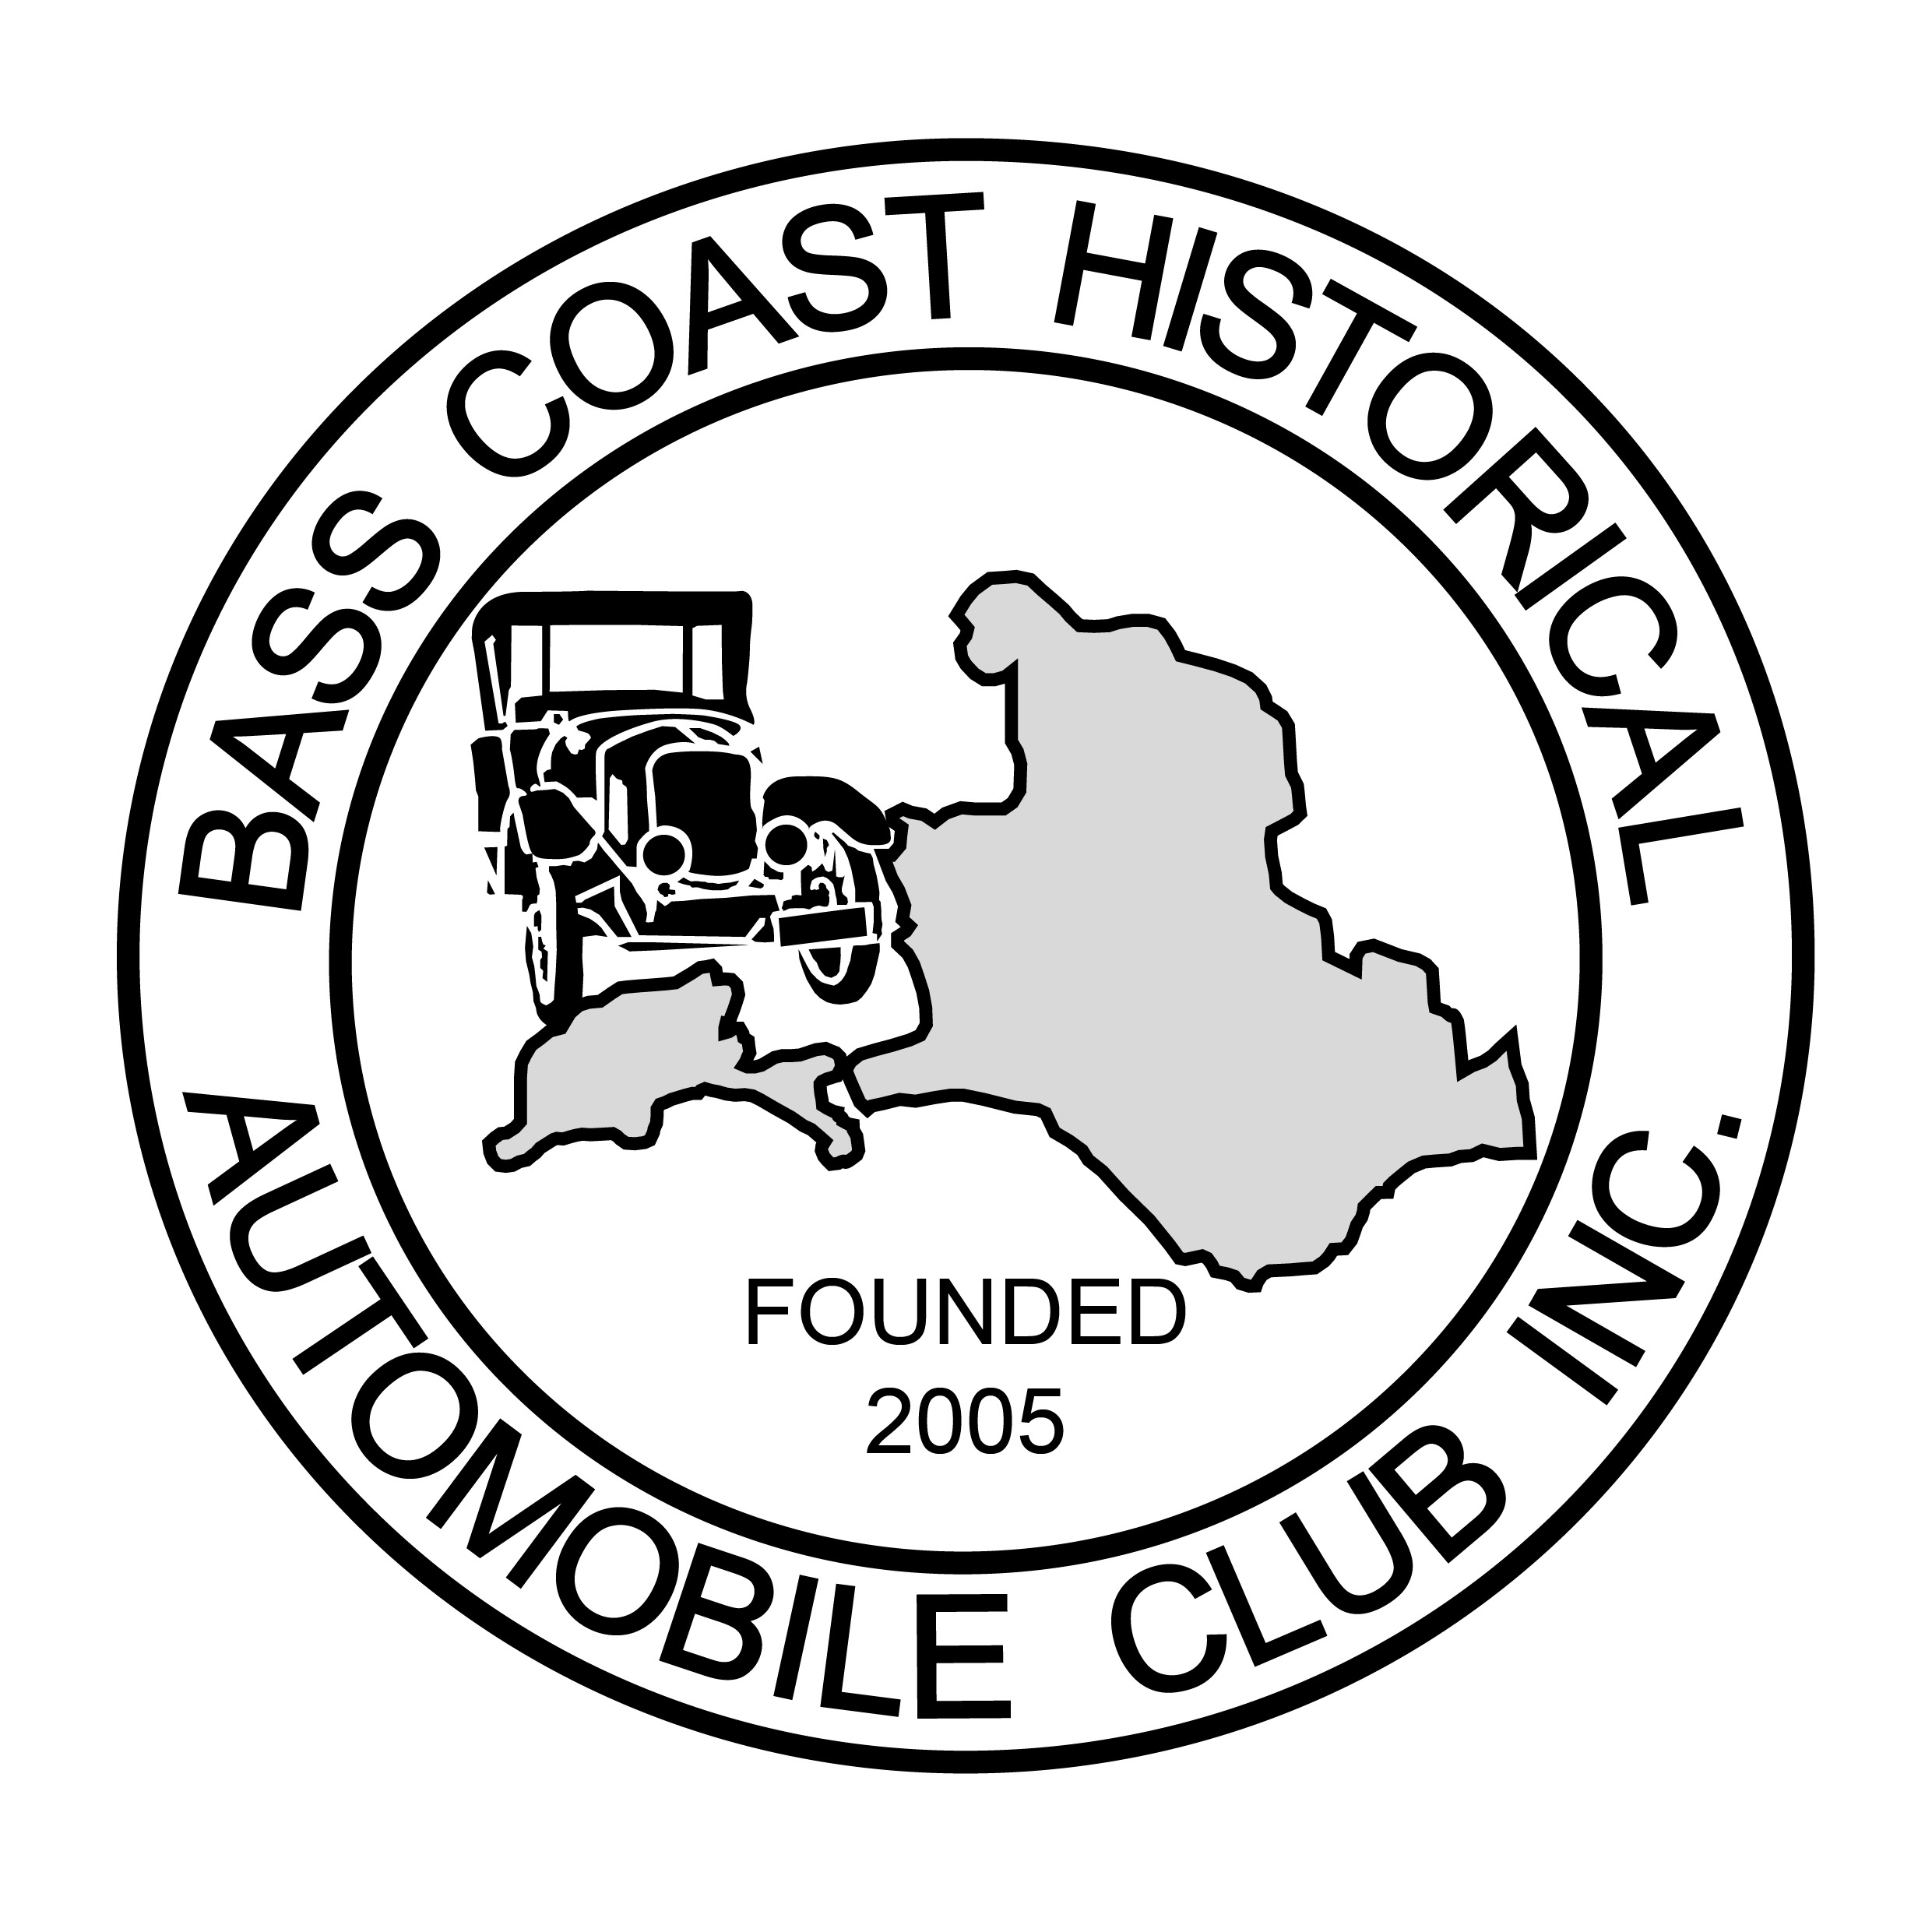
MEMBERSHIP NUMBER

Bass Coast Historical Automobile Club Inc.
P O Box 687, Wonthaggi, Vic 3995
Reg No. A0049447S

Application for Membership
Surname........................................................................Given Name.........................................................

Partner: Surname.............................................Given Name...............................................................
Residential Address....................................................................................Postal...............................................
Town/City................................................................................................Postcode..............
State............................................................................................
Contact Phone No...............................................................Mobile Phone No. ............................................
Email address .............................................................................................................................................
Ma  Make | Year | Model | Body Style or Engine Type | Permit No.  Reg. No. | Club Permit Due Date | Condition (Refer Code)
Condition Code: O=Original R=Restored UR=Under Restoration P=Parts
Signatures: Applicant.........................................................................Partner...................................................................
Introduced by Name.......................................................Signature....................................................M’ship No................
Seconded by Name................................................... ....Signature..................................................M’ship No.................

ANNUAL SUBSCRIPTION Full Year Half Year
1 July to 30 June if joining after 1 Jan

Subscription $50.00 $25.00
Joining Fee ....$20.00
Total Payment

Lodge completed form and payment with Membership Registrar or mail to P O Box 687 Wonthaggi 3995
Approved by the Committee .......................................................................
Receipt No..................................Date.....................................................
BY SIGNING THIS APPLICATION I/WE AGREE TO THE CONDITIONS ON THE REVERSE HEREOF
Signature/s....................................................................................................Date.................

CONDITIONS OF MEMBERSHIP
Membership Year - 1 July to 30 June
Members who remain unfinancial after the expiration of three (3) months from the end of the financial year will have their membership revoked.
Members must be financial for a period of not less than three (3) months and have attended a minimum of three (3) meeting or events before applying for a permit under the Club Permit Scheme.
CLUB PERMIT SCHEME
BCHAC Inc. is a Club authorised by VicRoads to administer the Club Permit Scheme
To apply for a permit under the Club Permit Scheme the applicant must provide a current Victorian Certificate of Roadworthiness and comply with the requirement of VicRoads which may be in place from time to time.
The Applicant must sign a Letter of Agreement with the Club when issued with a Club Permit, and must provide photographs of the vehicle as required from time to time by VicRoads
The Applicant must be bound by the By Laws of the Club
To apply for a permit under the Club Permit Scheme application MUST be made to the Club Permit Scheme Registrar or the Club Secretary.
PRIVACY
The information you have provided may be made available to Club Members from time to time via newsletter, website or annual list of members and vehicles.
This information may include names, addresses, contact numbers, personal and vehicle photos.
Please indicate in writing to the Secretary if you DO NOT WISH any information described above to be disclosed.
EMERGENCY CONTACTS
In the event of an emergency the Club needs to know the contact details of a responsible person known to you, preferable a person not accompanying you or travelling with you
NAME...................................................................................RELATIONSHIP...............................................
ADDRESS:.........................................................................................CONTACT NO....................................
INFORMATION ABOUT YOU
- Where/How did you hear about the Club?.....................................................................................
- What are your interests?
A) Car Shows and Displays......................................................................
B) Tours including weekends away.........................................................
C) Annual Rallies.......................................................................................
D) Social Events.........................................................................................
E) Other......................................................................................................

